1.27 Random Variables and Counters



This section will guide you to understand:

* How to use random variable and counters in JMeter

**Development Environment:**

* Apache JMeter 5.1.1 version

This guide has four subsections, namely:

1.27.1 Generating values by random variable element

1.27.2 Generating random values by _time()

1.27.3 Adding counter element

1.27.4 Pushing the code to GitHub repositories

**Step 1.27.1:** Generating values by random variable element

* Sometimes we need to generate random values in our JMeter scripts and then work with them in our requests. For example, instances where the URL requires an auto-generated and unique value as a parameter.
* There are many ways to do this in [JMeter](http://www.blazemeter.com/jmeter-load-testing?utm_source=blog&utm_medium=BM_blog&utm_campaign=three-ways-to-generate-random-variables-in-jmeter) and we will look at some of the most common ones.
* Adding random variable element:

1. Open JMeter.
2. Right click on the Test Plan.
3. Right click on Thread Group.
4. Click on Add -> Config Element -> Random Variable.

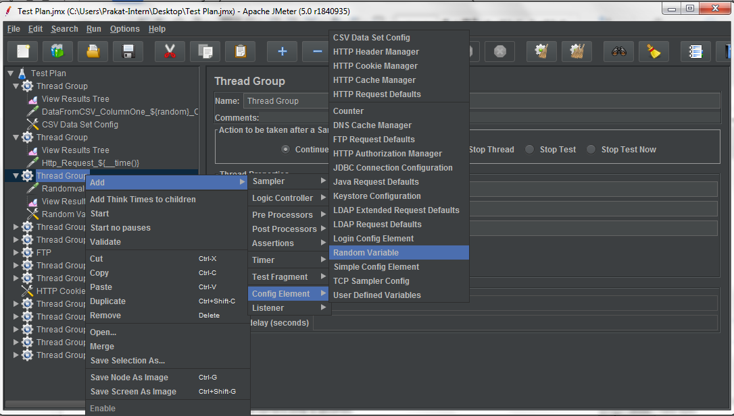

1. The sampler is as shown below and you need to fill in the required fields:

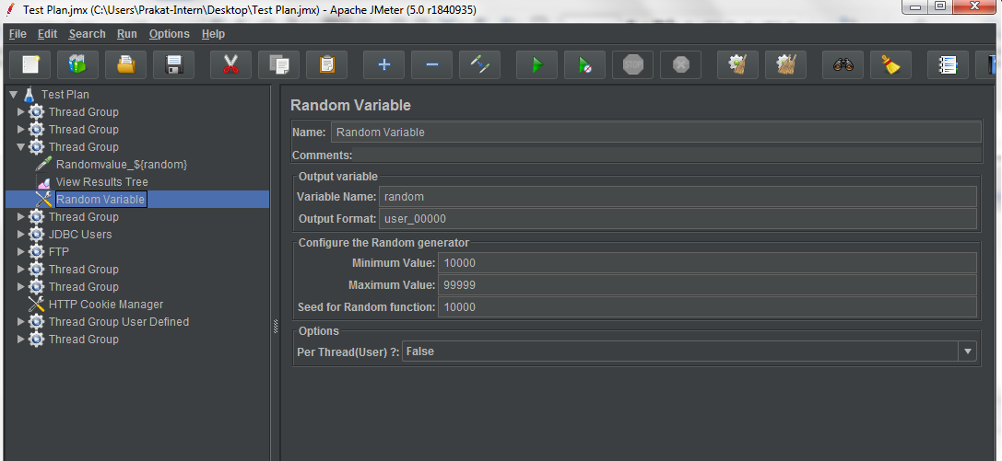

1. **Variable Name:** The name used to invoke the variable (Ex: random)
2. **Output Format:** The specified format for the variable (Ex: user_00000)
3. **Minimum and Maximum Value:** Range of the variable (Ex: 10000 to 99999)
4. **Per Thread:** If you set it to **True,** the value will be shared by the threads. This means that there will be threads with the same value. If you want to always generate a different value, you have to set it to  **False**.

* Adding HTTP request:

1. Right click on Thread Group.
2. Click on Add -> Sampler -> HTTP Request.

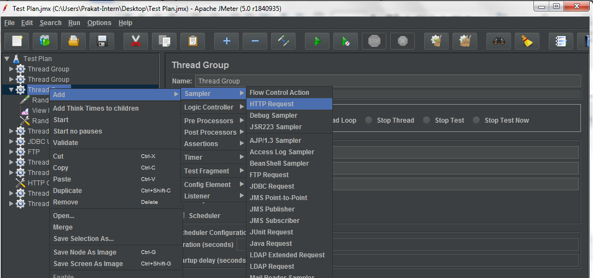

1. Rename HTTP request as “RandomValue_${random}” where random is the variable name specified in random variable element.
2. ${variable_name} is used to get the value of the variable.
3. Specify server name and path.

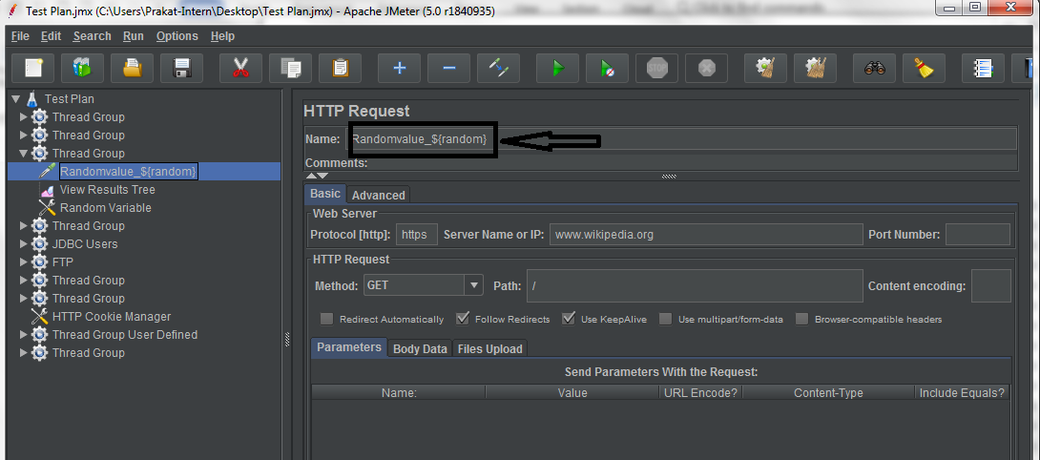

* Adding View Results Tree:

1. Right click on Thread Group.
2. Click on Add -> Listener -> View Results Tree.

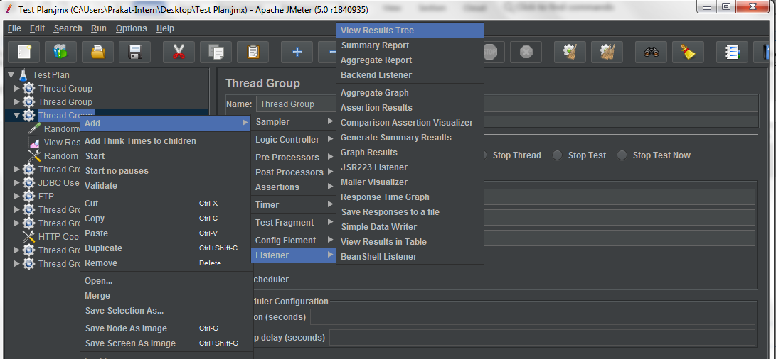

1. Open Thread Group.
2. Set the Loop Count to 10.

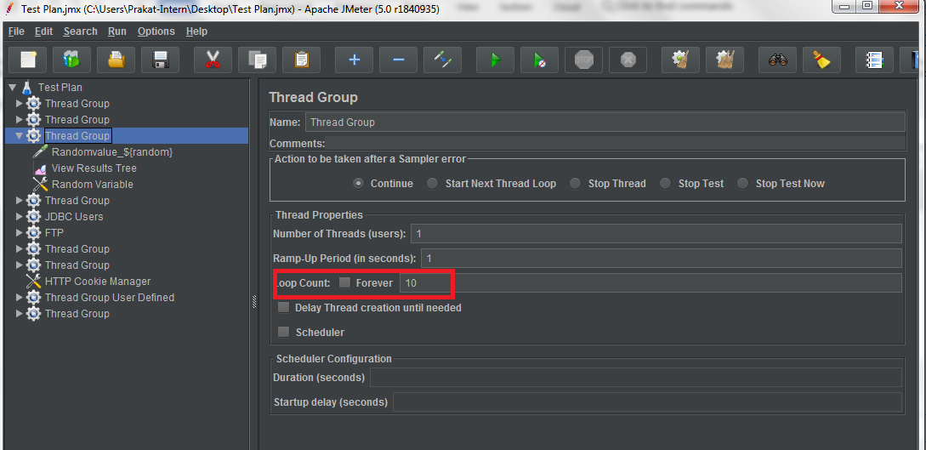

1. Run the Thread Group and open View Results Tree to see the output.

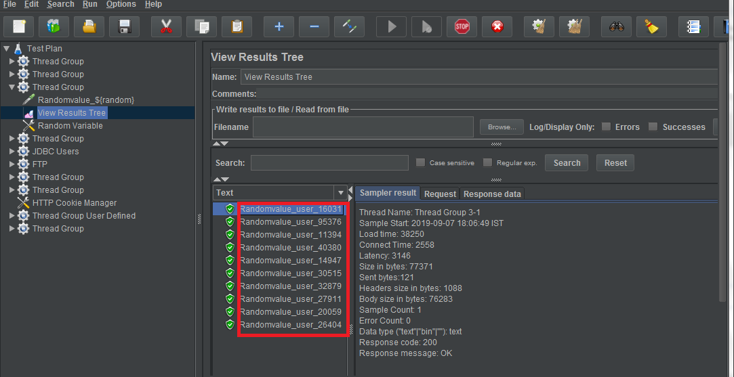

1. The mentioned 10 HTTP Request runs with different random values with specified format “user_00000” Ex: RandomValue_user_40380.

**Step 1.27.2:** Generating random values by _time()

* Adding users in thread group:

1. Right click on Test Plan.
2. Click on Add -> Threads(users) -> Thread Group.

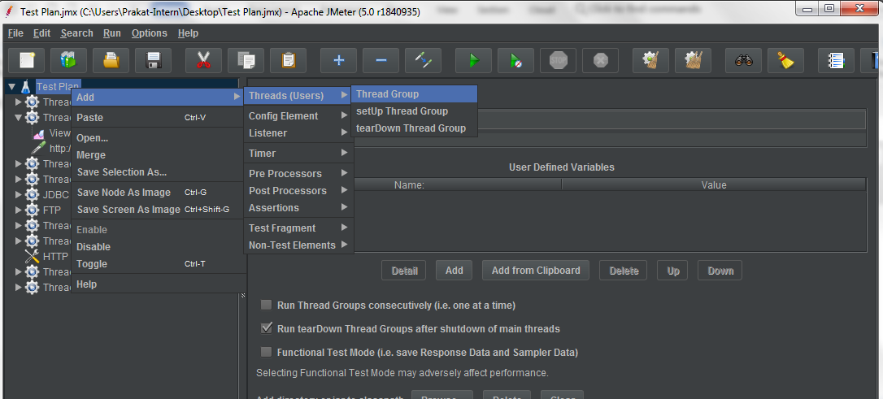

1. Set the Number of Threads to 3.

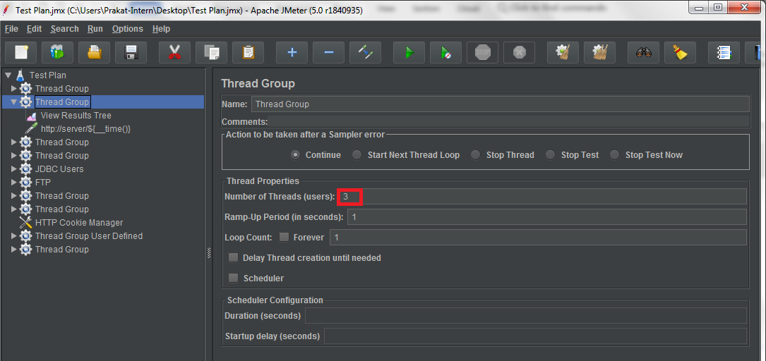

* Adding View Results Tree:

1. Right click on Thread Group.
2. Click on Add -> Listener -> View Results Tree.



* Adding HTTP Request:

1. Right click on Thread Group.
2. Click on Add -> Sampler -> HTTP Request.
3. Rename HTTP request to Http_Request_${__time()} , where “__time()” gives the current time in seconds.
4. Specify the server name and path in the HTTP request.

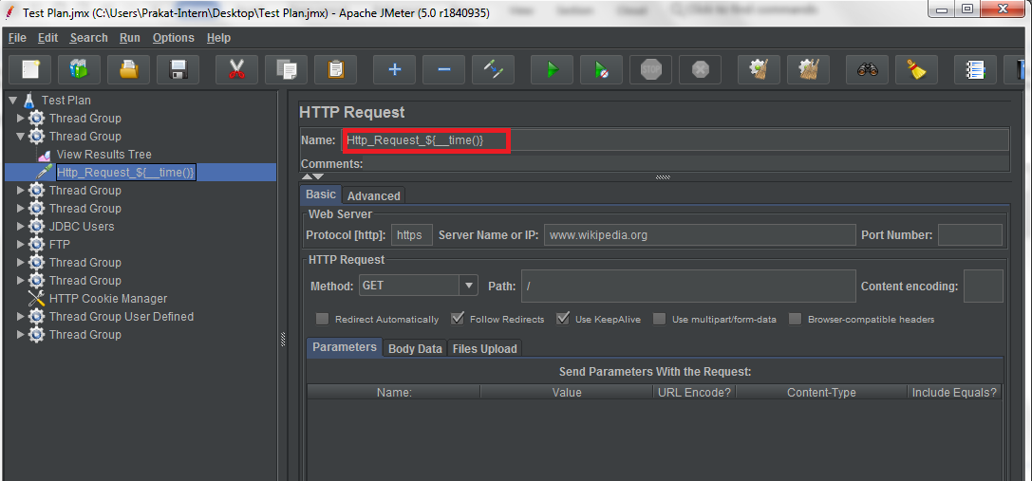

5. Run the Thread Group and Open the View Results Tree to see the output.

6. Three HTTP Requests run with different values.

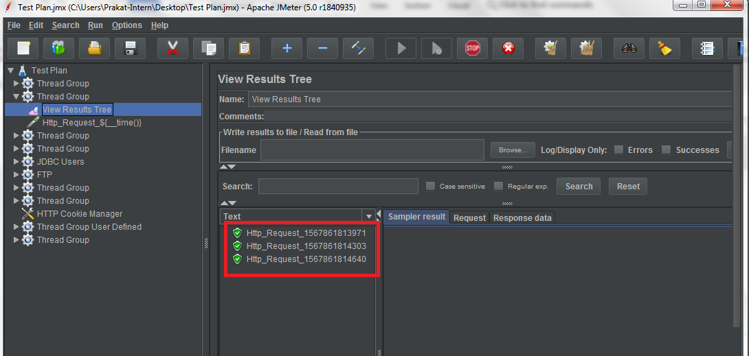

**Step 1.27.3:** Adding counter element

Let’s imagine a scenario in which you need to create five entities in a loop using the [HTTP Request](http://jmeter.apache.org/usermanual/component_reference.html#HTTP_Request) sampler and each entity name has to be unique. In this case, the better way is to use a [Counter](http://jmeter.apache.org/usermanual/component_reference.html#Counter) is by:

* Adding users in thread group:

1. Open JMeter.
2. Right click on the Test Plan.
3. Click on Add -> Threads(users) -> Thread Group.



1. Set the Loop Count to 10.

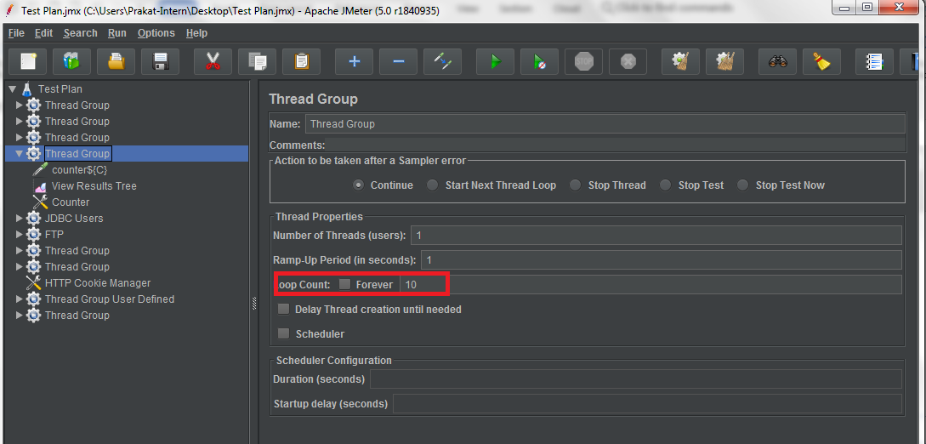

* Adding View Results Tree:

1. Right click on Thread Group.
2. Click on Add -> Listener -> View Results Tree.



* Adding Counter Element:

1. Right click on Thread Group.
2. Click on Add -> Config Element -> Counter.

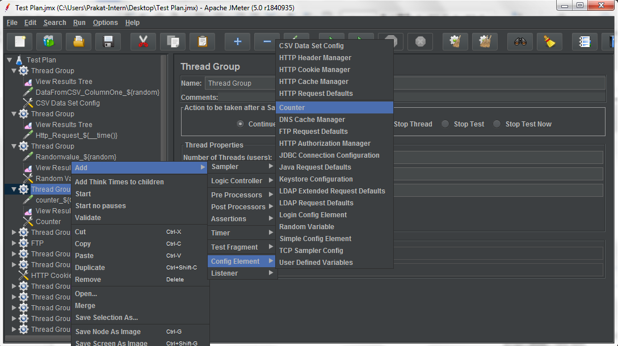

1. Enter the required fields in the counter.

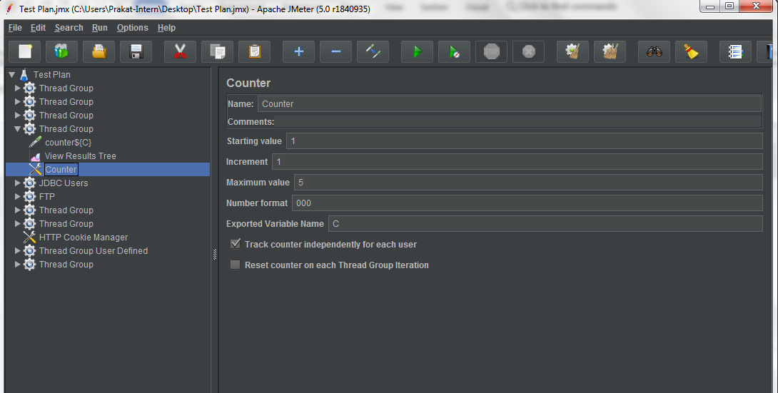

* + 1. **Starting value:** Initial counter value, Example: 1
    2. **Increment:** This value will be added to the current counter value once the counter is encountered (Ex: 1).
    3. **Maximum value:** When the current counter value exceeds “maximum” value, counter starts over. If it is left blank, the counter value will increase infinitely. Ex: if counter maximum value is five and number of threads are ten, then after counter value reaches five the counter value starts from 1.
    4. **Number format:** The number format will be Ex: 000.
    5. **Reference name:** The name used to invoke the variable (Ex: “C”)
* Adding HTTP Request:

1. Right click on Thread Group.
2. Click on Add -> Sampler -> HTTP Request.
3. Rename the HTTP Request to “counter_${C}” , where “C” is the reference name of the counter.
4. Enter the server name and path.

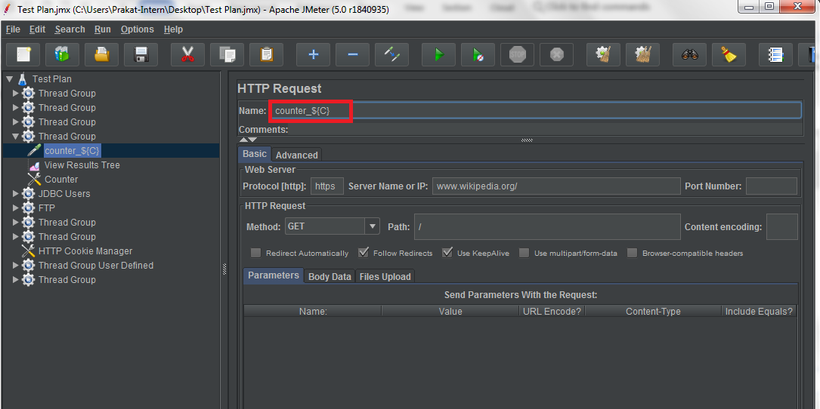

1. Run the Thread Group and open View Results Tree to see the output.

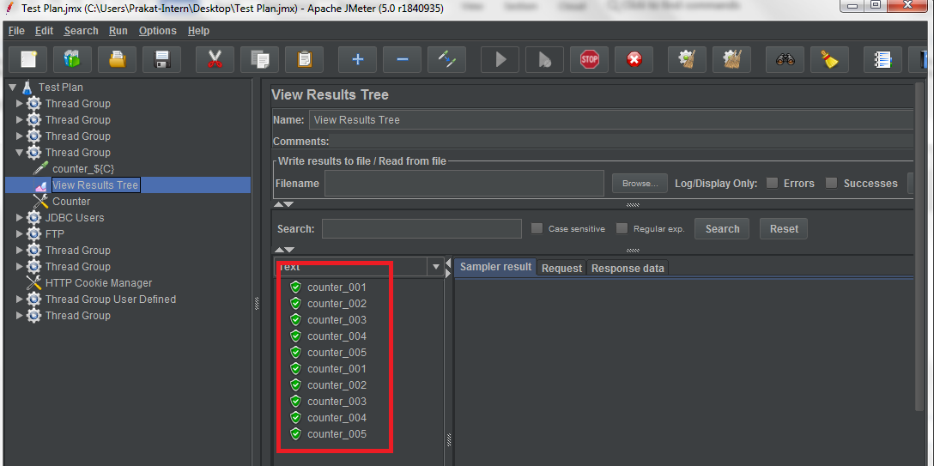

**Step 1.27.4:** Pushing the code to GitHub repositories

Open your command prompt and navigate to the folder where you have created your files.

cd <folder path>

Initialize your repository using the following command:

git init

Add all the files to your git repository using the following command:

git add . 

Commit the changes using the following command:

git commit . -m “Changes have been committed.”

Push the files to the folder you initially created using the following command:

git push -u origin master